**Probability and Statistics - IT2120**

**Lab Sheet 08**

**Name: Manthrirathna S.N**

**ID: IT24102791**

Question 1

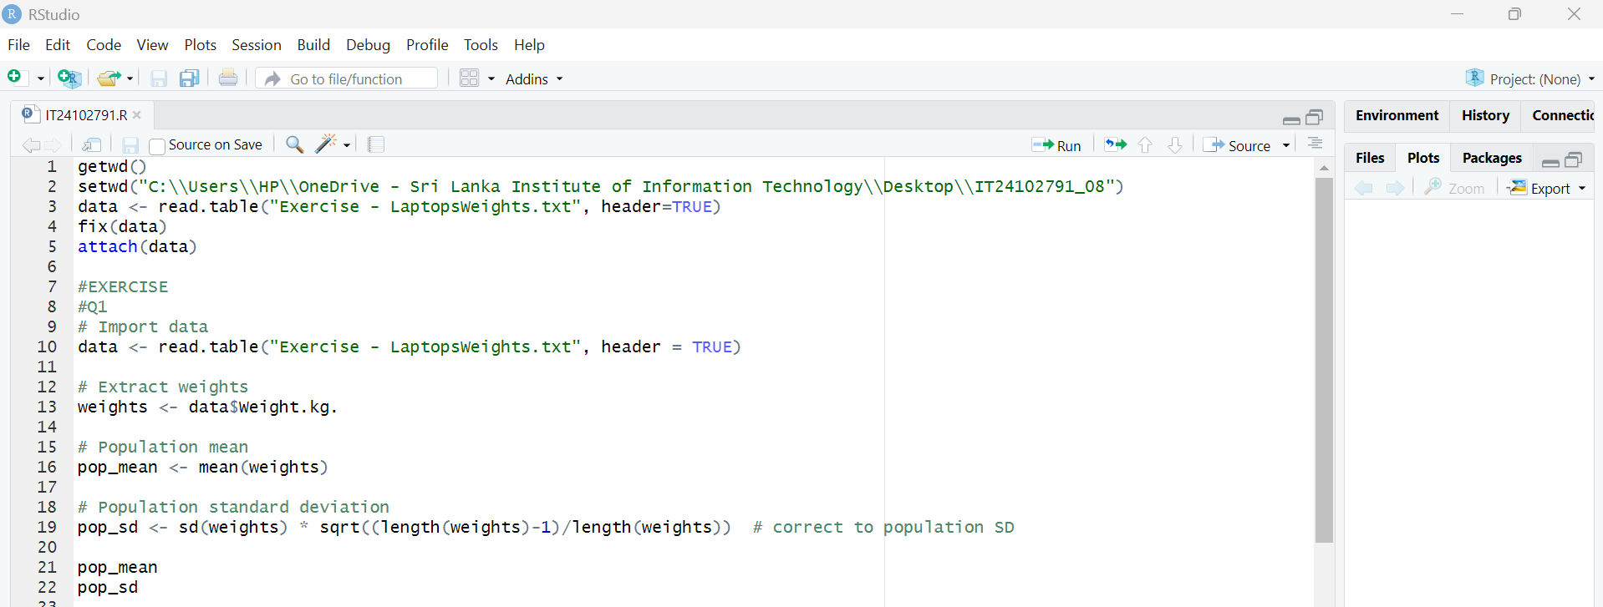

**Question 2**

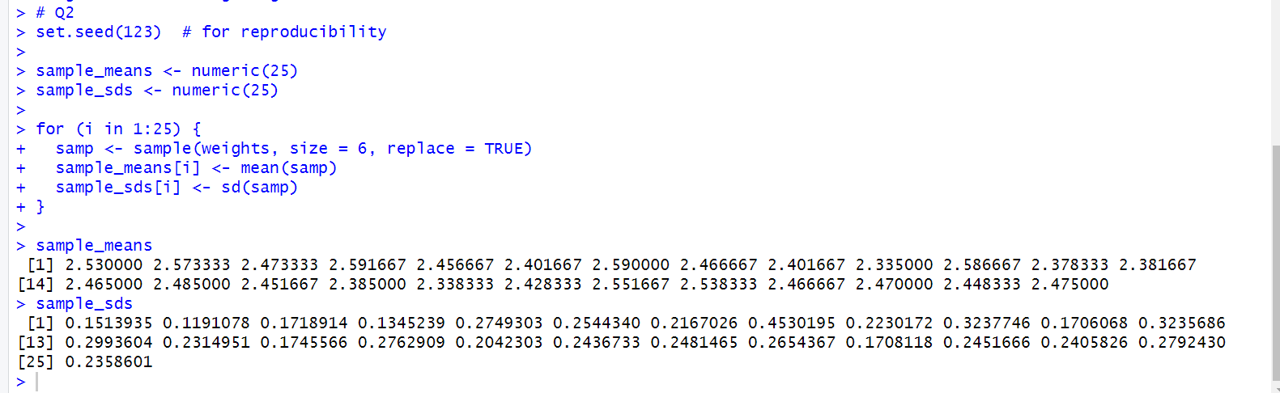

**Question 3**

